
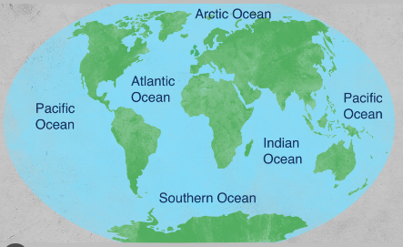
Oceans of the World
Summer 2024
Year 1 / Year 1.2

Science
Plants (see separate planning)
- Can you explain seed dispersal?
- Can you name three plants?
- What parts of a plant can we eat?
- Can we name the parts of a plant?
- Deciduous and Evergreen trees

Geography (Topic)

- Can you name the five Oceans and seven continents?
- Can you compare the weather here in Britain with Weather somewhere else in the world?
- Can you name sea animals and identify where in the world they live?
- To use Geographical vocabulary to describe human features/physical features.
- To identify hot and cold areas of the world.
PSHE / RE
- Being my best
- What can you do if you feel _______?
- Who can you discuss your feelings with when you’re at ____?
Introducing Bible Stories through characters and stories
- Noah’s Ark
- Why is the bible so important?
- Who are some of the important people?
- What can we learn from them?
Art & Design
- Can you create a sea animal using materials?
- Can you Paint using different textures and mixes of paints?
- Making moving mini-beasts
- Under the Sea collage

Computing

- Can you read 10 Bug Club books in 1 week?
- Program a robot (Beebot)
PE
- Dance skills
- Sports day practice
- Multi-skills training
- Skip-to-be-fit
Wow experiences
Lilidorei school trip
Skip-to-be-fit
Experience days (Literacy)
Spring walk
Dissecting Plants

Music / Dance
Your Imagination
- Charanga Summer 1

- Can you follow a rhythm and dance to the beat?

- Can you follow dance steps to create a routine?

