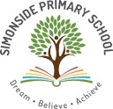
Reception Knowledge Organiser
Spring 2 – Africa

Key Texts / Canon of works

PSED
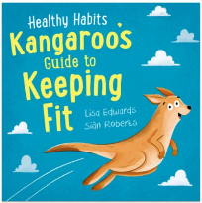
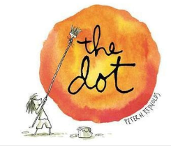
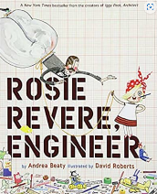

Literacy and Understanding the World
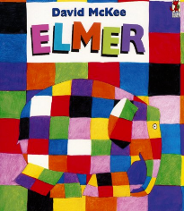
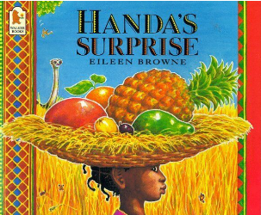
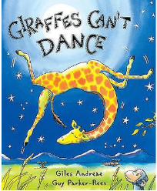
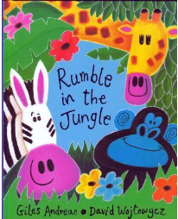



Key Concepts /Big Ideas.

Where do we live?
Where is Africa?
Where is Kenya?
How is Africa different to living in Newbiggin Hall and the Arctic?
What is the weather like in Africa?
What animals live in Africa?
How do animals keep cool in hot conditions?
What are the homes like in Kenya?
What are the schools like in Kenya?

Key Vocabulary linked to Key Concepts above

Africa – is the second largest continent. Africa is south of Europe and between the Atlantic and Indian Oceans.
Continent – a large area of land.
Habitat - a place where plants and animals live.
Survive – to stay alive.
Savannah – flat grassland with scattered trees.
Safari – a journey into the wilderness to look at free roaming wildlife.
Herbivore – an animal that doesn’t eat meat.
Environment – the natural world of the land, sea and air.
Camouflage – colour or covering that makes animals look like their surroundings.
Facilities - a building or buildings, made or used for a particular activity.
Community – a group of people living in a particular area.
Village – a community made up of a small number of homes, where people live near one another and share facilities.
Predator - an animal that hunts, catches and eats other animals.
Celebrations and experiences
World Book Day
Trip to Northumberland Zoo
Mother’s Day
Christians – People who believe that Jesus is the son of God.
Easter – The most important festival in the Christian calendar. It celebrates Jesus coming back to life.

Knowledge and Skills taught - Remembered Curriculum

Communication and Language   | Personal, Social and Emotional Development   | Physical Development   | Literacy   | Mathematics   | Understanding the World   | Expressive Art and Design  
Listening:  Understand why listening is important.  Attention:  Maintain attention in different contexts, attend to peers and adults that are familiar and unfamiliar  Respond:  Keep play going in response to the ideas of others and engage in conversation relevant to play theme. Use talk to help work out problems and organise thinking and activities explain how things work and why they might happen. Listen to and talk about selected non-fiction to develop a deep familiarity with new knowledge and vocabulary.  Understanding:  Ask questions to clarify understanding of a text or task. Ask questions to find out more and check understanding. Retell a story with exact repetition.  Speaking:  Use talk to clarify thinking, connect ideas and share thinking with others. Articulate their ideas and thoughts in well-formed sentences. Retell/create own stories for teacher scribing. Use simple conjunctions ‘and’, ‘because’. Use talk to help work out problems and organise thinking and activities. | Express feelings:  Can name people in school they can turn to if they help or are worried. Understand how to use the ‘take 5’ breathing exercise to help with big feelings.  Manage behaviour:  Understand why listening is important and attend to other people both familiar and unfamiliar.  Self-awareness:  Happy to stand up in front of the class and share achievements with others Know and talk about the different factors that support their overall health and wellbeing: regular physical activity healthy eating toothbrushing sensible amounts of ‘screen time’ having a good sleep routine.  Independence:  Can get dressed and undressed for nature school sessions. Begin to show persistence when faced with challenges Knows how to be a safe pedestrian. Can talk about healthy and unhealthy foods.  Collaboration:  Knows it is important to work together to look after our classroom resources and our school grounds. Can keep play going by cooperating, listening, speaking, and explaining. Can reflect on the work of others and self-evaluate their own work.  Social skills:  Use language to negotiate, play and organise.  SCARF Unit - – Being my best  Bouncing back when things go  Wrong.  Yes, I can  Healthy eating  My healthy mind  Move your body  A good night’s sleep  5 Short Stories: Eat Healthy, Be Healthy, and Smile!!! | Magic Frog Tales | PE lessons - Further develop and refine a range of ball skills including: throwing, catching, kicking, passing, batting, and aiming.  Develop their small motor skills so that they can use a range of tools competently, safely, and confidently. Suggested tools: pencils for drawing and writing, paintbrushes, scissors, knives, forks, and spoon. | COMPREHENSION  Retell stories in the correct sequence, draw on language patterns of stories. With prompting, show understanding of many common words and phrases in a story that is read aloud to them. Suggest how an unfamiliar story read aloud to them might end. Give a simple opinion on a book they have read, when prompted. Recognise repetition of words or phrases in a short passage of text. Play influenced by experience of books. Innovate a well-known story with support.  WORD READING  Blend sounds into words, so that they can read short words made up of known letter-sound correspondences.  Read a few common exception words matched to our phonic programme.  Read some letter groups that each represent one sound and say sounds for them. Read simple phrases and sentences made up of words with known letter–sound correspondences and, where necessary, a few exception words.  WRITING  Emergent writing:  Build words using known letter-sound correspondences in own writing.  Composition:  Orally compose a sentence and say how many words are in the sentence.  Spelling:  Spell to write VC, CVC and CVCC words independently using Phase 2 and phase 3 graphemes. Spell some irregular common (tricky) words e.g. the, to, no, go independently.  Handwriting:  Holds a pencil effectively to form recognisable letters. Know how to form clear ascenders and descenders.  Phonics:  Phase 2/3  Know grapheme/phoneme correspondence for all single letter sounds  Know how to blend with known letters for reading VC and CVC words.  Know how to blend to read and segment to spell VC and CVC words.  Including digraphs;  ff,ll,ss,ck,ng, sh,ch, th  and new vowel digraphs  ai, ee, igh oa oo ar  Consolidate previously taught sight words. Know new sight words - she, they, are  Write graphemes and begin to write digraphs when they hear them.  Know high-frequency common words (is, and, to, the no, go, into, I, of, has, his, as) | Compare weight and begin to measure using non-standard units.  Continue and compose repeating patterns.  Compare capacity and begin to measure using non-standard units.  Compose and decompose shapes so that children recognise a shape can have other shapes within it, just as numbers can.  Select, rotate and manipulate shapes in order to develop spatial reasoning skills. | Scientific Knowledge development  Animals (Safari)  Know the correct basic scientific vocabulary to describe parts of animals.  Know what animals need to survive in Africa/Safari  Know and explain where a range of animals live e.g. talk about animals which live in a cold and hot places (while looking at Arctic/Antarctic and hot places while looking at Africa) Describe both habitats and compare and contrast.  Scientific Vocabulary  Polar animals (Penguin, Artic fox, Orca, Elephant seal, Polar Bear, Snowy Owl), frozen, camouflaged, survival.  Safari animals ( Hippopotamus, Elephant, Zebra, Lion, Rhinocerus, Giraffe, Leopard, Cheetah, Ostrich, Crocodile)  Enquiry Skill Development  Use technology to make observations or find information about different locations and places. Recognise, know, and describe features of Africa ( compare and contrast to Arctic Regions and the UK)  Understand some important processes and changes in the natural world around them, including the seasons and changing states of matter - water to ice.  Past and Present  People, Culture and Communities  Respect  Understand the value of being curious and interested in finding out about people and animals living in other countries – special places, events or objects – through non-fiction texts, stories, visitors and celebrations.  Describe special events - Easter  Enquiry:  Know about some key historical events – know why and how we celebrate today?  Easter  The Natural World  Know that the weather is changing and Spring is on its way.  Know the order of the four seasons.  Comment on what they notice about the environment where they live and understand the effect of the changing seasons on the natural world around them and how this impacts on the animals living in African regions especially.  Describe what they see, hear, and feel outside. | Mark Making/Drawing:  Skill::show different emotions in their drawing e.g. happiness, sadness. Draw with increasing complexity and detail, such as representing a face with a circle and including details.  Colour:  Skill: to be able to create a wash background and combining colour in the style of Joan Miró.  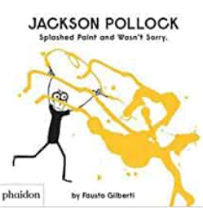  Painting:  Experience: explore different paint types - watercolour, powder paint, acrylic, ready mix paint.  Printing:  Skill: printing with natural objects/food e.g. leaves, pine cones.  Materials:  Knowledge: understand the purpose of different textiles/materials. e.g. winter clothing  3D Work:  Skill: creating work to celebrate special days e.g. decorations (paper chains, bunting) for lunar new year, valentine's Day.  Cutting Skills:  Use scissors to cut out shapes with straight and curved lines.  Songs and Rhyme Knowledge  Poetry Basket:  Pancakes  Spring Wind  Furry furry squirrel  Hungry Birdies  A Little Seed Mrs Bluebird  Charanga Songs:  OUR WORLD  Old Macdonald Incy Wincy Spider Baa Baa Black Sheep Row, Row, Row Your Boat The Wheels On The Bus The Hokey Cokey

