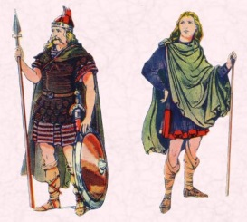
Rights Respecting
Our lessons will have a focus on covering a range of the 41 articles.

Art

Children will develop their painting skills.
Skills:
- To create sketch books to record their observations and use them to review and revisit ideas.
- To improve their mastery of art and design techniques, including drawing, painting and sculpture with a range of materials
- Learn about great artists, architects and designers in history.

Application of maths across the curriculum: Measuring, proportion, shape
Application of literacy across the curriculum: Reading and following instructions.

Geography
Children will learn about France.

Skills:
- Locate the world’s countries, using maps to focus on Europe (including the location of Russia) and North and South America, concentrating on their environmental regions, key physical and human characteristics, countries, and major cities.
- Name and locate counties and cities of the United Kingdom, geographical regions and their identifying human and physical characteristics, key topographical features (including hills, mountains, coasts and rivers), and land-use patterns; and understand how some of these aspects have changed over time.
- Identify the position and significance of latitude, longitude, Equator, Northern Hemisphere, Southern Hemisphere, the Tropics of Cancer and Capricorn, Arctic and Antarctic Circle, the Prime/Greenwich Meridian and time zones (including day and night).
- To understand geographical similarities and differences through the study of human and physical geography of a region of the United Kingdom, a region in a European country, and a region in North or South America.
- Describe and understand key aspects of physical geography, including: climate zones, biomes and vegetation belts, rivers, mountains, volcanoes and earthquakes, and the water cycle.
- Describe and understand key aspects of human geography, including: types of settlement and land use, economic activity including trade links, and the distribution of natural resources including energy, food, minerals and water.

Application of maths across the curriculum: Grid reference (co-ordinates), comparing data (population etc)
Application of literacy across the curriculum: Reading and retrieving information (comprehension skills)

Music
Children will learn to sing, play, improvise and compose using Charanga!

Skills:
- Play and perform in solo and ensemble contexts, using their voices and playing musical instruments with increasing accuracy, fluency, control and expression.
- Improvise and compose music for a range of purposes using the interrelated dimensions of music.
- Listen with attention to detail and recall sounds with increasing aural memory.
- Use and understand staff and other musical notation appreciate and understand a wide range of high-quality live and recorded music drawn from different traditions and from great composers and musicians
- Develop an understanding of the history of music.

Application of maths across the curriculum: Counting/calculating the beats in a bar.
Application of literacy across the curriculum: Using rhyme and alliteration.

Computing

Year 3 - Creating media – Desktop publishing

Year 4 - Creating media – Photo editing

Skills:
- Design, write and debug programs that accomplish specific goals, including controlling or simulating physical systems; solve problems by decomposing them into smaller parts
- Use sequence, selection, and repetition in programs; work with variables and various forms of input and output
- Use logical reasoning to explain how some simple algorithms work and to detect and correct errors in algorithms and programs
- Understand computer networks including the internet; how they can provide multiple services, such as the world-wide web; and the opportunities they offer for communication and collaboration
- Use search technologies effectively, appreciate how results are selected and ranked, and be discerning in evaluating digital content
- Select, use and combine a variety of software (including internet services) on a range of digital devices to design and create a range of programs, systems and content that accomplish given goals, including collecting, analysing, evaluating and presenting data and information.
- Use technology safely, respectfully and responsibly; recognise acceptable/unacceptable behaviour; identify a range of ways to report concerns about content and contact.
Application of maths across the curriculum: problem solving, shape, space and measure, direction, coordinates, times tables. Application of literacy across the curriculum: Speaking and listening, instructions, reading, comprehension.

Wow experiences
France Day

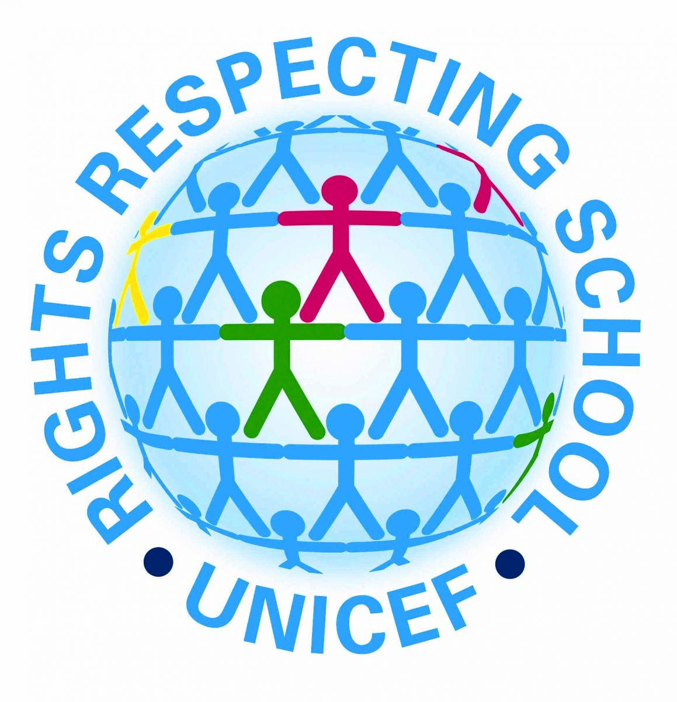

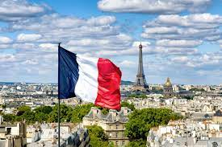

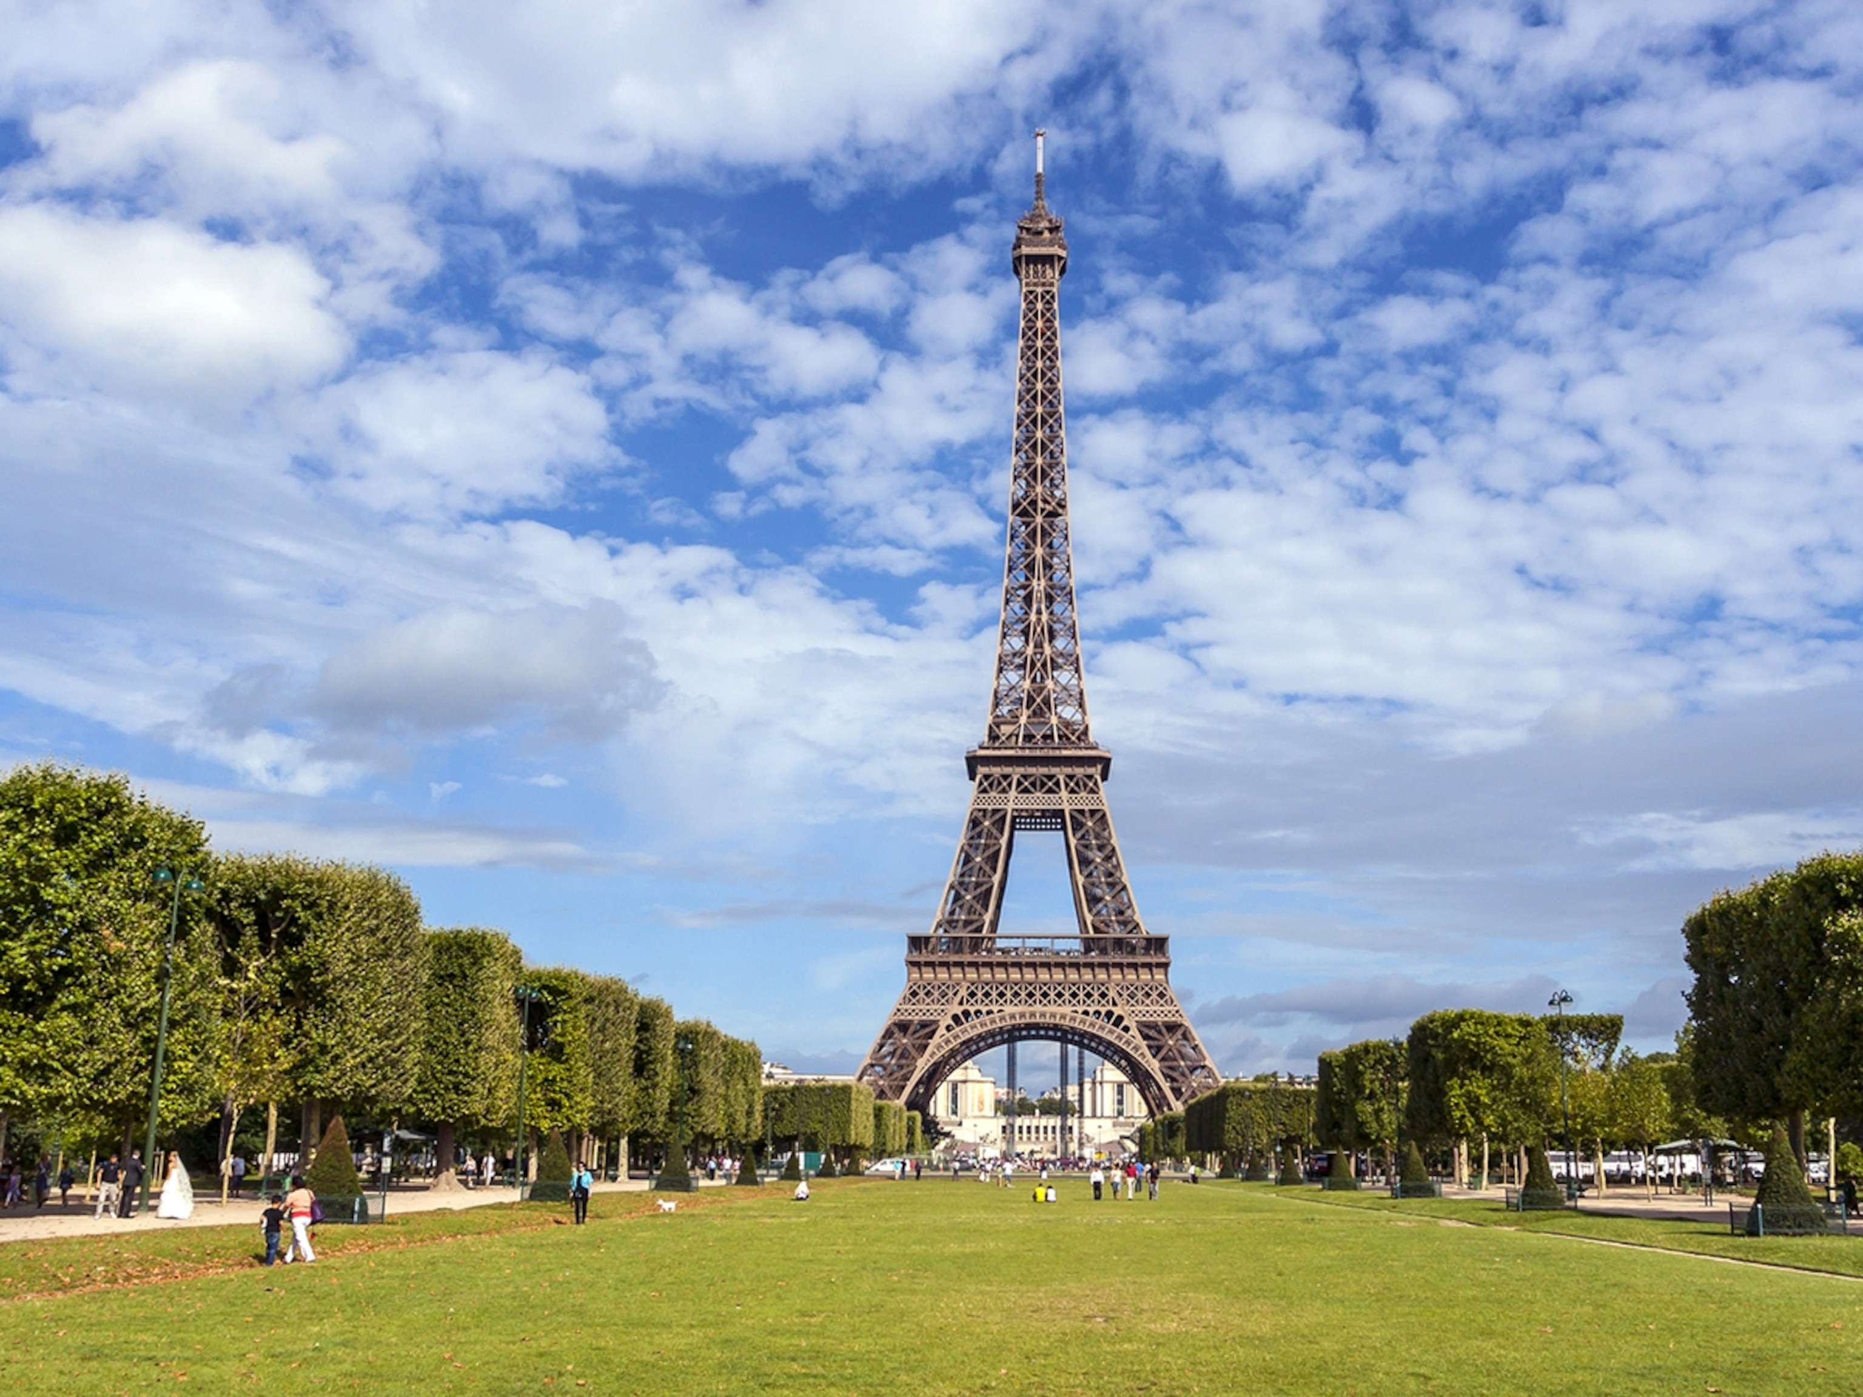
France
(Spring 1)
Religious Education

Year 3

Pilgrimages and rituals in different religions.

Year 4
Hinduism-God and worship in the home

Skills:
- Present the key teachings and beliefs of a religion, making references to religious figures.
- Identify religious artefacts and buildings and explain why they are used.
- Identify religious symbolism in literature and the arts.
- To reflect
- To understand values.

PSHE

In PSHE lessons, the theme will be ‘Keeping Safe’.

Application of literacy across the curriculum: speaking and listening

PE
This term the children will focus on developing their Boccia and Gymnastics skills.

Skills:
- Children will develop spatial awareness and ability to run and dodge.
- Children will develop the ability to jump in a variety of ways and hop over a short distance.
- Children will develop the ability to maintain balance.
- Children will develop the ability to roll a ball.
- Children will develop the ability to throw a ball using one hand towards a target.

Application of maths across the curriculum: Time, distance, conversion between measurements.
Application of literacy across the curriculum: instructions, speaking and listening.

