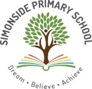
Reception Knowledge Organiser
Autumn 2 – What do different groups of people celebrate during the Autumn months of the year?

Key Texts / Canon of works

Literacy
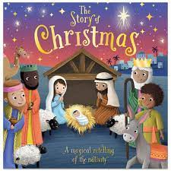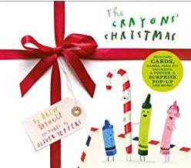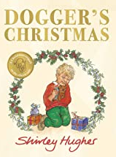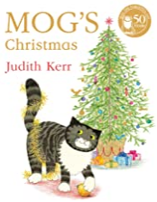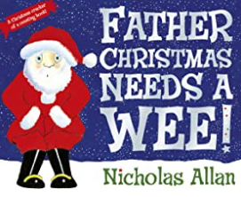

Understanding the World
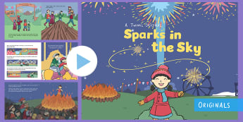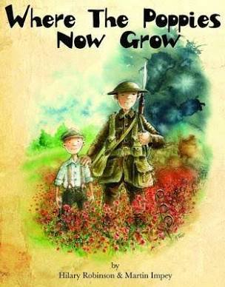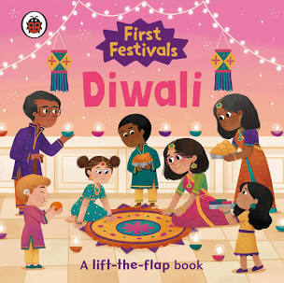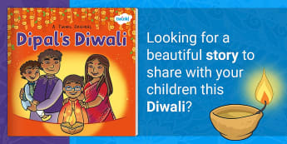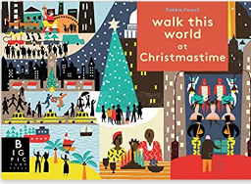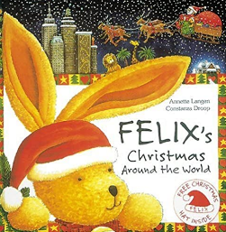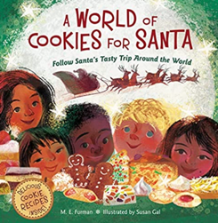


Key Concepts /Big Ideas.

Festivals are a time of celebration.

Festivals are celebrated in all cultures by lots of different people and religions around the world.

People celebrate in lots of different ways including decorating their homes, eating special food and wearing special clothes.

Festivals can also be a time to remember.
Halloween. 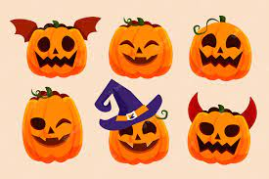 Remembrance Day. 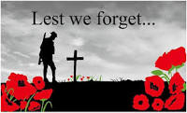 Bonfire Night.  Diwali. 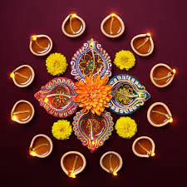 Christmas. 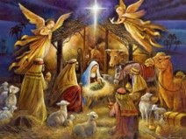

Key Vocabulary linked to Key Concepts above

Halloween: the night of 31st October, the eve of All Saints Day.
Remembrance Day: in memory of those killed in the war.
Poppy: the first flower to grow in the fields after the war had ended. The flower we wear to remember.
Bonfire Night: a festival on 5th November in memory of the Gunpowder Plot.
Diwali: Hindu festival of light.
Rangoli: Colourful Indian decorations.
Religion: a set of beliefs held by a group of people.
Christmas: a festival celebrated by Christian people.
Nativity: story of the birth of Jesus Christ.
Knowledge and Skills taught - Remembered Curriculum

Communication and Language   | Personal, Social and Emotional Development   | Physical Development  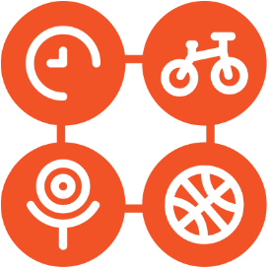 | Literacy   | Mathematics  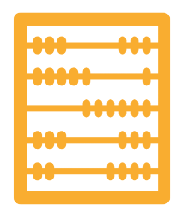 | Understanding the World   | Expressive Art and Design  
Listening:  Listen in familiar and new situations.  Engage in stories that are familiar and new with interest and enjoyment.  Attention:  Maintain attention in new situations e.g., whole school assembly or PE sessions in the hall.  Shift attention when required e.g., when given a clear prompt - ‘name’.  Respond:  Make relevant comments when listening to a story and can answer ‘why’ questions.  Link events in a story to their own experiences.  Ask questions to find out more and to check they understand what has been said to them.  Respond to others appropriately in play.  Engage in story times.  Engage in non-fiction book.  Understanding:  Follow instructions or a question with 2 parts in familiar situations.  Speaking:  Use intonation to make meaning clear to others.  Start a conversation with peers and familiar adults and continue it for many turns.  Use simple conjunctions in talk to link thoughts ‘and’ ‘because’.  Retell a simple event e.g., how scratched knee’ Recognise words that rhyme or sound similar E.g., “Cat and hat”.  Develop social phrases – “Good morning, how are you?” | Express feelings:  Know how to show concern for others and show awareness of how their actions may impact on others.  Express their feelings and consider the feelings of others.  Manage behaviour:  Begin to take turns and share resources.  Can usually tolerate delay when needs are not immediately met.  Self-awareness:  Can talk about what they are doing and why.  Independence:  Know areas they would like to play in or resources they would like to use and independently access.  Know they can say when they help.  With some support, know how to get dressed and undressed for PE sessions.  Can follow instructions with 2 parts.  Collaboration:  Begin to share and take turns.  Social skills:  Continue to build constructive and respectful relationships.  Know familiar adults and peers to engage in conversations and ask for help.  PSED – SCARF - Valuing Difference  Be sensitive towards others and celebrate what makes each person unique.  Recognise that we can have things in common with others.  Use speaking and listening skills to learn about the lives of their peers.  Know the importance of showing care and kindness towards others.  Demonstrate skills in building friendships and cooperation.  Links to Relationships Education within this half termly unit.  Families and people who care for me  Caring friendships  Respectful relationships  Anti Bullying Week /World Kindness Day  Know what it means to be kind  How can we show kindness  Why is ot good to be kind  Who to go to, to ask for help if someone isnt showing kindness | Fundamental movement skills  In PE sessions and outdoors  rolling, crawling, walking, jumping, running, hopping, skipping,  Develop their small motor skills so that they can use a range of tools competently, safely, and confidently. Suggested tools: pencils for drawing and writing, paintbrushes, scissors, knives, forks, and spoon. | COMPREHENSION  Engage in conversation and can answer questions when reading wordless fiction and nonfiction books.  Know how to respond to ‘who’, ‘where’ ‘what’ and ‘when’ questions linked to text and illustrations.  Know how to talk about events, feelings, main characters, where a story is set and recognise links to own life experiences.  WORD READING  Read individual letters by saying the sounds for them.  Blend sounds into words, so that they can read short words made up of known letter-sound correspondences.  Read a few common exception words matched to our phonic programme.  WRITING  Emergent writing:  Copies adult writing behaviour e.g., writing on a whiteboard, writing messages.  Makes marks and drawings using increasing control.  Know there is a sound/symbol relationship.  Knows some recognisable letters and own symbols.  Write letters and strings, sometimes in clusters like words.  Composition:  Learn to orally compose a sentence and say how many words are in the sentence.  Spelling:  Knows how to orally spell VC and CVC words by identifying the sounds.  Knows how to write own name.  Handwriting:  Knows how to form letters from their name correctly.  Knows that after a word there is a space.  Phonics:  Phase 2  Know grapheme phoneme correspondence of 19 letters.  Know how to blend with known letters for reading VC and CVC words.  Know how to orally segment for VC and CVC words for spelling  Know high-frequency common words (the, to, no, go). | Shapes with 4 sides  Know that squares and rectangles have 4 straight sides and 4 corners  Know how to recognise these shapes on everyday items  One more one less  Begin to the know the link to between counting forwards and the one more pattern and counting backwards and the one less pattern.  Exploring pattern - making simple patterns, odd one out, exploring more complex patterns.  Time - Night and Day  Know how to order key events in daily routines.  Know language to describe when key events happen e.g., day, night, morning, afternoon, tomorrow, before, after.  Begin to know how to measure time in simple ways e.g., counting the number of sleeps to an important event, using timers to measure duration of events. | Past and Present  Remembrance Day is a celebration of the soldiers who died fighting in the war for us.  We wear poppy flowers to remember the soldiers in WW1 and WW2.  People, Culture and Communities  Enquiry:  Know about some key historical events – know why and how we celebrate today? Remembrance Day, Christmas Day, Diwali.  Diwali is a Hindu festival of light. Hindu people create Rangoli patterns on the floors of their homes and mehndi patterns on their hands. They wear special clothes and eat special food and have lights and candles in their homes.  On Bonfire night we have fireworks and we know how to stay safe around them.  Christmas is a time when Christian people remember the birth of Jesus. Christmas is celebrated by putting up Christmas decorations and lights and exchanging presents.  Respect:  Know that that people have different beliefs and celebrate special times in different ways.  Begin to know some similarities and differences between life in this country and life in other countries.  The Natural World  Know that the leaves fall off the trees in Autumn.  Name the 4 seasons of the year.  Name some of the items we find outside in Autumn – conkers, fir cones, acorns.  Know what is Harvest?  Know that the weather changes in Autumn.  Know that some birds migrate to warmer countries in Autumn.  Know that the weather is changing and Winter is on its way next after Autumn.  Impact:  Know how to use the language of time when talking about past/present.  Chronology:  Begin to know how to use the language of time when talking about past/present events in their own lives and in the lives of others including people they have learnt about through books. | Mark Making/Drawing:  Skill: observational drawing - Pumpkins  Know how to create closed shapes with continuous lines and begin to use these shapes to represent objects.  Colour:  Recognise and name colours.  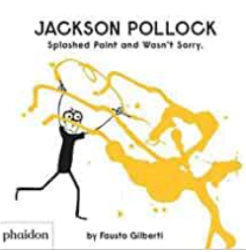  Painting:  Artist study – Know that Jackson Pollock created splatter paintings.  Know how to collaborate with others to create artwork.  Printing:  Know how to print using hands and fingers.  Materials:  Know how to use different materials for Junk modelling. Junk modelling will continue to be offered in continuous  provision.  3D Work:  Know how to use simple joins when using different materials to create 3D work, e.g., Sellotape, masking tape,  stick glue.  Cutting Skills:  Know how to use scissors to cut in a straight line.  Songs and Rhyme Knowledge  Poetry Basket:  Know the following songs  I’m a little elf  In My Christmas Den  Out of the Corner of My Eye  Robin is my name  Whether the weather  Charanga Songs:  Pat-a-cake  1, 2, 3, 4, 5, Once I Caught a Fish Alive  This Old Man  Five Little Ducks  Name Song  Things For Fingers  Christmas Nativity production songs.

