
Reception Knowledge Organiser
Summer 1 – Once Upon a time………. How does your garden grow?

Key Texts / Canon of works

PSED

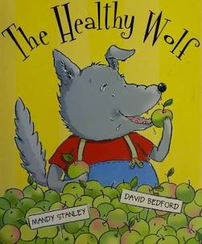

Literacy and Understanding the World

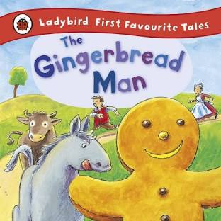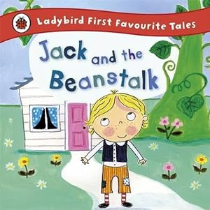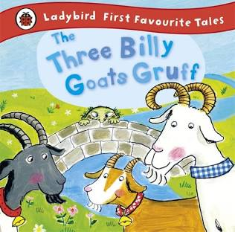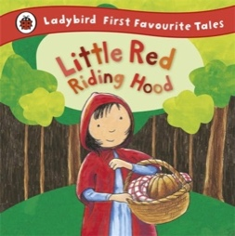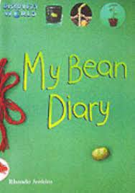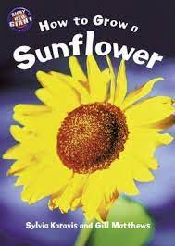


Key Concepts /Big Ideas.

What is Spring and what happens outside during this time?
How does Spring fit into the cycle of seasons?
How do plants grow?
What is the life cycle of a sunflower and a bean plant?
What do plants need to grow healthy and strong?
What are the parts of a plant called?

What is a traditional story?
What language is always used in a traditional story? i.e. Once upon a time, happily ever after.

Key Vocabulary linked to Key Concepts above

Spring – a season of the year coming after Winter / a time when plant life begins to grow again after the winter.

Seeds and bulbs – once planted in the soil grow into flowers, plants and trees.

Parts of a plant – seed, root, stem, leaves, flower.

Life cycles of a plant – What changes happen as it grows?

Once upon a time……

Happily ever after…….

Characters, events, ending……

Celebrations and experiences

Planting our own flower and vegetable seeds and watching them grow.
Healthy food picnic.

Knowledge and Skills taught - Remembered Curriculum

Communication and Language   | Personal, Social and Emotional Development   | Physical Development   | Literacy   | Mathematics   | Understanding the World   | Expressive Art and Design  
Listening:  Listen to and understand instructions about what they are doing, whilst busy with another task  Attention:  Listen and continue with an activity for a short time.  Respond:  Keep play going in response to the ideas of others and engage in conversation relevant to play theme.  Ask and answer ‘what’, ‘where’, ‘when’, and ‘what could we do next’ questions.  Listen to and talk about selected non-fiction to develop a deep familiarity with new knowledge and vocabulary.  Understanding:  Carry out a series of 3 directions. Show familiarity with selected non-fiction by using new knowledge and vocab in conversation and play. Understand ‘how’, ‘why’ and ‘where’ questions.  Speaking:  Recount an event in the correct order and some detail.  Give details that they know are important and will influence the listener E.g., “Ahmed fell over that stone, Javid didn’t push him”.  Express ideas about feelings and experiences.  Articulate their ideas in well-formed sentences.  Show that they can use language to reason and persuade E.g. “Can I go outside because it’s stopped raining?” | Express feelings:  Initiate an apology where appropriate. Beginning to know that children think and respond in different ways to them.  Manage behaviour:  Can follow instructions, requests, and ideas in a range of situations.  Self-awareness:  Can talk about their own abilities positively.  Independence:  Confident to try new activities and say why they like some activities more than others.  Show resilience and perseverance, a belief that with more effort or with a different approach success will occur.  Understands rules linked to road safety.  Can follow directions with 3 parts.  Collaboration:  Know it is important for all of us to keep safe when using and transporting tools, equipment, and resources.  Social skills:  Can be considerate to the needs of others, beginning to respect a different point of view and work together in collaboration.  SCARF UNITS COVERED  Focus – Safety in the home ( SCARF – Keeping Safe  Name some hazards and ways to stay safe inside and outside.  How to care for the safety of others.  Focus – Keeping myself safe – What’s safe to go into my body – including medicines. ( SCARF – Keeping Safe  Focus – SCARF Being my best – Healthy Eating  Understand how to make healthy food choices.  Name and recognise healthy food /drink choices.  Eating in moderation – which foods can we eat ‘just sometimes’. | Develop the foundations of a handwriting style which is fast, accurate and efficient.  Continue to develop their small motor skills so that they can use a range of tools competently, safely, and confidently. Suggested tools: pencils for drawing and writing, paintbrushes, scissors, knives, forks, and spoon.  Fine motor skills are the small movements used for control and precision during activities.  It is important to recognise that the development of fine motor skills happens through daily access to resources, activities and opportunities provided through continuous provision e.g., threading, play dough, building and creating, colouring, puzzles etc. All areas of learning are interconnected and not all learning has a predetermined outcome.  Develop the overall body strength, co-ordination, balance, and agility needed to engage successfully with future physical education sessions and other physical disciplines including dance, gymnastics, sport, and swimming.  Combine different movements with ease and fluency.  PE  Further develop and refine a range of ball skills including: throwing, catching, kicking, passing, batting, and aiming.  Develop confidence, competence, precision and accuracy when engaging in activities that involve a ball.  Move energetically, such as running, jumping, dancing, hopping, skipping and climbing. | COMPREHENSION  Correctly sequence a story or event using pictures and/or captions.  Make simple, plausible suggestions about what will happen next in a book they are reading.  Know the difference between different types of texts (fiction, nonfiction, poetry)  Make inferences to answer a question beginning 'Why do you think…?' in a picture book that has been read to them, where answer is clearly signposted.  Play influenced by experience of books - gestures and actions used to act out a story, event or rhyme from text or illustrations.  WORD READING  Read some letter groups that each represent one sound and say sounds for them.  Read simple phrases and sentences made up of words with known letter–sound correspondences and, where necessary, exception words.  WRITING  Emergent writing:  Continue to build on knowledge of letter sounds to build words in writing. Use writing in play. Use familiar words in their writing. Write more graphemes from memory and write a simple sentence using phonic knowledge.  Composition:  Write simple sentences and captions using capital letter, finger spaces and full stops.  Spelling:  Spell words by drawing on knowledge of known grapheme correspondences.  Make phonetically plausible attempts when writing more complex unknown words.  Handwriting:  Form most lower-case letters correctly, starting and finishing in the right place, going the right way round and correctly orientated.  Include finger spaces between words.  Phonics Phase 3  Consolidate phase 2 and 3 skills.  Know vowel digraph ai, ee, igh, oa, oo, oo, or, ar, er, ow, oi, ear, air, er  Read tricky words from phase 2 and phase 3.  Continue to apply knowledge of blending and segmenting to reading and spelling simple two-syllable words and captions. | NUMBER  Understand the ‘one more than/one less than’ relationship between consecutive numbers.  Explore the composition of numbers to 10.  Automatically recall number bonds for numbers 0–10.  Verbally count beyond 20, recognising the pattern of the counting system.  Compare quantities up to 10 in different contexts, recognising when one quantity is greater than, less than or the same as the other Quantity`.  Explore and represent patterns within numbers up to 10, including evens and odds, double facts.  SHAPE  Compose and decompose shapes so that children recognise a shape can have other shapes within it, just as numbers can.  Identify, name and describe 3d shapes. | SCIENTIFIC KNOWLEDGE AND DEVELOPMENT  What is Spring and what happens outside during this time?  How does Spring fit into the cycle of seasons?  How do plants grow?  What is the life cycle of a sunflower and a bean plant?  What do plants need to grow healthy and strong?  What are the parts of a plant called?  THE NATURAL WORLD  SCIENTIFIC VOCABULARY  Spring – a season of the year coming after Winter / a time when plant life begins to grow again after the winter.  Seeds and bulbs – once planted in the soil grow into flowers, plants and trees.  Identify and name parts of a plant – seed, root, stem, leaves, flower.  Life cycles of a plant – What changes happen as it grows?  ENQUIRY  Understand some important processes and changes in the natural world around them, including the seasons and changing states of matter.i.e. life cycles / growth and change.  PAST AND PRESENT  PEOPLE AND COMMUNITIES  ENQUIRY  Find out about the lives of famous artists from the past – Van Gough and Monet. | Children will experience and develop a range of creative, artistic skills. The children will have daily, continuous access to a wide range of open ended, ambiguous resources allowing the opportunity to explore, experiment and develop their own creativity. They will have the opportunity to create collaboratively sharing Ideas and resources as well on solo work. Throughout the year the children will have the opportunity to return to and build on their previous learning, refining ideas and developing their ability to represent them. In addition, specific skills and/or experiences will be planned (see below).  Marking Making/Drawing: observational drawing – daffodils, Sunflowers  Show accuracy and care in their drawing.  Colour: identifying shades of colour and how to make different shades.  Painting: explore working with paint on different surfaces and in different ways i.e., coloured, sized, and shaped paper. Explore using different brush types.  3D Work: Making own props/puppets to retell a story. Folding techniques e.g., fans, aeroplanes, books. Choosing materials for effect.  Cutting Skills: use scissors independently.  Artist Study: Van Gogh and Monet  Poetry Basket:  I have a little frog Dance  Five little peas Pitter Patter  Monkey Babies If I were so very small  Charanga Songs:  Big Bear Funk (a transition unit that prepares children for their musical learning in Year 1)  Being Imaginative:  Invent, adapt and recount narratives and stories with peers and their teacher. Creates representations of both imaginary and real-life ideas, events, people and objects.  Uses combinations of art forms, e.g. moving and singing, making and dramatic play,  drawing and talking, constructing, and mapping

