
Reception Knowledge Organiser
Spring 1 – Compare and contrast – The Arctic/Antarctica to where we live.

Key Texts / Canon of works

PSED

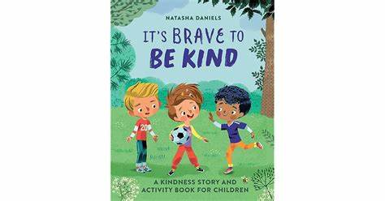
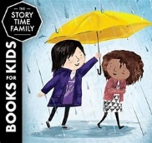
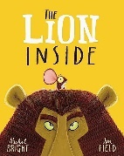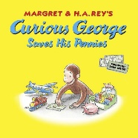

Literacy and Understanding the World

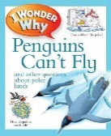
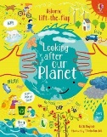
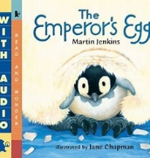
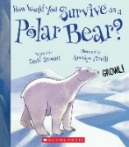
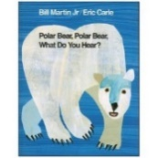
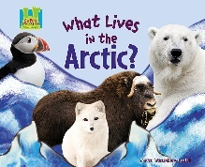
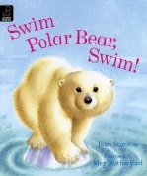
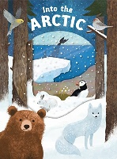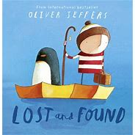

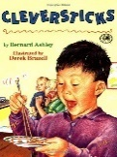


Key Concepts /Big Ideas.

Where do we live?
Where is the Arctic/Antarctic and how is it different to living in Newbiggin Hall?
What are the weather/conditions like in the Arctic and Antarctic?
What animals live in the Arctic? Antarctic?
How do animals keep warm in the icy conditions?
What colour are Arctic animals?
Why don’t polar bears eat penguins?
Why can’t penguins fly?
What would happen if all the polar ice melted?
Do people live in the Arctic? Antarctic?

PSE - How do we take care of our teeth?

Key Vocabulary linked to Key Concepts above

Arctic – the frozen area around the North pole
Antarctic – the area around the South Pole
Iceberg - a huge piece of floating ice in the sea
Habitat - a place where plants and animals live
Survive – to stay alive
Environment – the natural world of the land, sea and air
Camouflage – colour or covering that makes animals look like their surroundings.
Blubber - the fat under the skin of a whale or seal
Fur – the soft hairy coat of an animal
Chinese New Year : a festival that celebrates the beginning of a new year on the traditional lunisolar Chinese calendar.

Knowledge and Skills taught - Remembered Curriculum

Communication and Language   | Personal, Social and Emotional Development   | Physical Development   | Literacy   | Mathematics   | Understanding the World   | Expressive Art and Design  
Listening:  Listen attentively in a range of situations and know how to listen carefully e.g. understand they need to look at who is talking to them and think about what they are saying.  Attention:  .Maintains attention, concentrates, and sits quietly during appropriate activity for a short time in the classroom  Respond:  Make predictions about what might happen next or story endings in response to texts read. Engage in non-fiction books. Link events in a story to their own experiences. Introduce a storyline into their play.  Understanding:  Consider the listener and takes turns to listen and speak in different contexts.  Speaking:  Use talk to pretend objects stand for something else in play. Demonstrate use of past tense verbs, such as "ran" or "fell" but may still get confused. Offer explanations for why things happen. Describe events that happen in their day | Express feelings:  Can show pride in achievements by showing work to others. Can make choices and communicate what they need.  Manage behaviour:  Understand behavioural expectations of the setting  Self-awareness:  Take pride in themselves, work, and achievements. Can explain right from wrong and try to behave accordingly  Independence:  Can independently manage their own needs; eating, drinking, accessing snack when hungry and communicate own needs in relation to being thirsty, hungry, tired, using the toilet.  Collaboration:  Consider the listener and takes turns to listen and speak in different contexts. Can identify kindness and considerate behaviour of others.  Social skills:  Seek others to share activities and experiences.  SCARF Unit  – Rights and Respect  Looking after my special people.  Looking after my friends  Being helpful at home and caring for my classroom  Caring for our world  Looking after money: spending, saving and keeping it safe.  Taking care of our bodies – our teeth.. | Further develop and refine a range of ball skills including throwing, catching, kicking, passing, batting, and aiming. Develop confidence, competence, precision, and accuracy when engaging in activities that involve a ball.  Develop their small motor skills so that they can use a range of tools competently, safely, and confidently. Suggested tools: pencils for drawing and writing, paintbrushes, scissors, knives, forks, and spoon.  PE sessions – continue to practice fundamental movement skills children have acquired last term. Develop ball skills of throwing, catching, kicking and passing. | COMPREHENSION  Use picture clues to help read a simple text. Make a simple prediction based on the pictures or text of a straightforward story that is read aloud to them. Show understanding of some words and phrases in a story that is read aloud to them. Express a preference for a book, song or rhyme, from a limited selection. Play is influenced by experience of books (small world, role play).  WORD READING  Read individual letters by saying the sounds for them.  Blend sounds into words, so that they can read short words made up of known letter-sound correspondences.  Read a few common exception words matched to our phonic programme.  Read some letter groups that each represent one sound and say sounds for them. Read simple phrases and sentences made up of words with known letter–sound correspondences and, where necessary, a few exception words.  WRITING  Emergent writing:  Copies adult writing behaviour e.g., writing on a whiteboard, writing messages.  Makes marks and drawings using increasing control.  Know there is a sound/symbol relationship.  Knows some recognisable letters and own symbols.  Write letters and strings, sometimes in clusters like words.  Build words using known letter-sound correspondences in own writing  Composition:  Learn to orally compose a sentence and say how many words are in the sentence.  Spelling:  Knows how to spell VC and CVC words by identifying the sounds.  Knows how to write own name.  Handwriting:  Recognise that after a word there is a space. Show a dominant hand.  Write from left to right and top to bottom.  Begin to form some recognisable letters.  Phonics:  Phase 2/3  Know grapheme/phoneme correspondence for all single letter sounds  Know how to blend with known letters for reading VC and CVC words.  Know how to segment to spell VC and CVC words for spelling  Including digraphs; ff,ll,ss,ck,ng, sh,ch, th  Know high-frequency common words (is, and, to, the no, go, into, I, of, has, his, as) | Count objects, actions and sounds beyond 10.  Link the number symbol with its cardinal number value beyond 10.  Compare numbers and understand the ‘one more/one less than’ relationship between consecutive numbers  Subitise.  Explore the composition of numbers to 10.  Simple addition and subtraction.  Compare length, weight of objects and begin to measure using non standard units. | Scientific Knowledge development  Animals (Polar and Safari) Know the correct basic scientific vocabulary to describe parts of animals.  Know what animals need to survive in Arctic conditions.  Know and explain where a range of animals live e.g. talk about animals which live in a cold and hot places (while looking at Arctic/Antarctic and hot places while looking at Africa) Describe both habitats and compare and contrast.  Scientific Vocabulary  Polar animals (Penguin, Artic fox, Orca, Elephant seal, Polar Bear, Snowy Owl), frozen, camouflaged, survival.  Safari animals ( Hippopotamus, Elephant, Zebra, Lion, Rhinocerus, Giraffe, Leopard, Crocodile)  Enquiry Skill Development  Use technology to make observations or find information about different locations and places. Recognise, know, and describe features of Antarctica. Understand some important processes and changes in the natural world around them, including the seasons and changing states of matter - water to ice.  People, Culture and Communities  Know about how people live in the Arctic. How is this the same or different to the way we live?  Enquiry:  Know about some key historical events – know why and how we celebrate today? Valentines Day  The Natural World  Know that the weather is changing and Winter is here.  Know the order of the four seasons.  Comment on what they notice about the environment where they live and understand the effect of the changing seasons on the natural world around them and how this impacts on the animals living in Polar regions especially.  Describe what they see, hear, and feel outside. | Mark Making/Drawing:  Skill::show different emotions in their drawing e.g. happiness, sadness. Draw with increasing complexity and detail, such as representing a face with a circle and including details.  Colour:  Skill: to be able to create a wash background and combining colour in the style of Joan Miró.  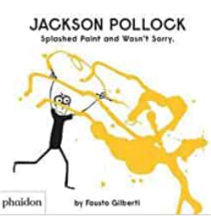  Painting:  Experience: explore different paint types - watercolour, powder paint, acrylic, ready mix paint.  Printing:  Skill: printing with natural objects/food e.g. leaves, pine cones.  Materials:  Knowledge: understand the purpose of different textiles/materials. e.g. winter clothing  3D Work:  Skill: creating work to celebrate special days e.g. decorations (paper chains, bunting) for lunar new year, valentine's Day.  Cutting Skills:  Use scissors to cut out shapes with straight and curved lines.  Songs and Rhyme Knowledge  Poetry Basket:  Know the following songs  Popcorn  A little house  Let's put on our mittens  I can build a snowman Carrot Nose  Charanga Songs:  EVERYONE!  Wind The Bobbin Up  Rock-a-bye Baby  Twinkle,Twinkle  If You're Happy And You Know It  Head, Shoulders, Knees And Toes  Also introduce songs linked to them of the Arctic regions.

