
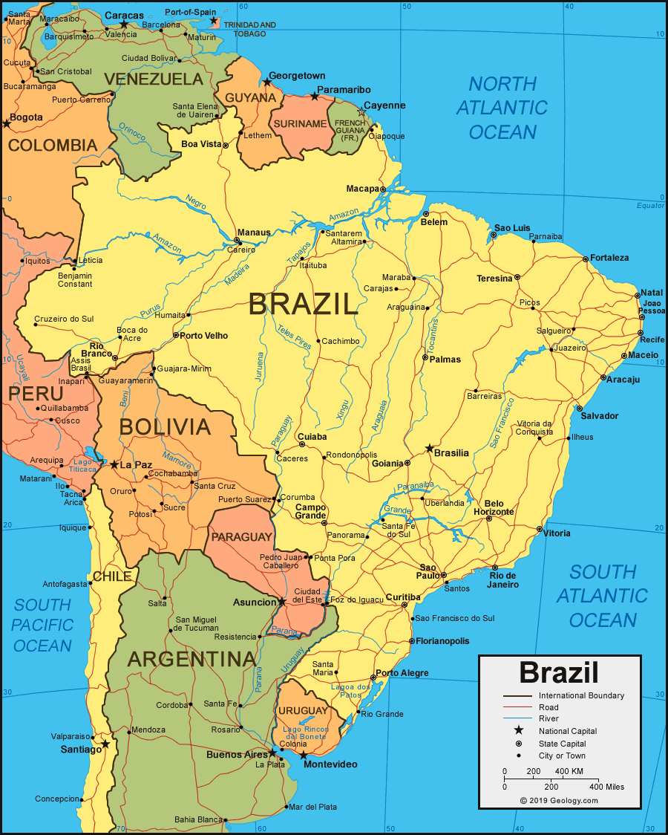
Brazil- A study of a region within South America.

Art and Design

Painting- Capturing conflict.
Children will be learning to give details about the style of notable artists and create original pieces that show a range of influences and styles. They will also show how the work of those studies was influential in both society and to other artists.

Application of maths across the curriculum: Shape

Application of literacy across the curriculum: instructions, speaking and listening

PSHE and Rights Respecting

Health and Wellbeing-Healthy Lifestyles
Children will be looking at how images in the media and reality can affect how people feel. They will also look at the risks and effects of drugs. They will recognise what they are good at, set goals and discuss aspirations.

Rights Respecting
Article 17—The right to access reliable information from the media.
Article 12 – The right to be listened to.
Article 13-The right to research and share what you find.
Skills:
Application of maths across the curriculum: Weighing, measuring food
Application of literacy across the curriculum: speaking and listening

MUSIC
Livin’ on a prayer
In this unit, all lessons will focus around one song: Livin’ On A Prayer.
The lessons provide an integrated approach to music where games, the dimensions of music (pulse, rhythm, pitch), singing and playing instruments are all linked.
Skills:
- To identify and move to the pulse with ease.
- To communicate the meaning of the words and clearly articulate them.
- Create simple melodies using up to five different notes and simple rhythms that work musically with the style of the Unit song.
- Improvise using instruments in the context of a song to be performed.
- Play a musical instrument with the correct technique within the context of the Unit song.
Application of maths across the curriculum: Counting/calculating the beats in a bar.
Application of literacy across the curriculum: Using rhyme and alliteration.

Religious Education
Places of Worship:
We will be looking at religious buildings and how they exemplify the beliefs and values of religious communities. This work will enable the children to further their knowledge of signs and symbols.

Skills:
- Classify different types of religious buildings and objects and know they have different meanings to different users.
- Know that beliefs, ideas and feelings can be expressed in a variety of ways.
- Give reasons for the relative significance of different objects and relate them to the teachings of Christianity.
- To know about the beliefs of different Christian denominations

Application of maths across the curriculum: Pattern and shape in architecture
Application of literacy across the curriculum: speaking and listening

Application of maths across the curriculum: pattern and shape in architecture
Application of literacy across the curriculum: speaking and listening

Computing
Computer systems and network communications

Children will learn about search engines, how to refine their searches to get more specific results and how searches are influenced. They will also discuss ways of communicating on the internet and the best ways to communicate in different scenarios. They will look at how to stay safe while communicating online and how to do this responsibly.

Application of literacy across the curriculum: instructions, speaking and listening

Application of literacy across the curriculum: instructions, speaking and listening

Wow experiences
- Swimming lessons
- Bikeability
- Funky Foods assembly

History/Geography

This half term the children will understand geographical similarities and differences through the study of human and physical geography of a region or area within North or South America.

We will set off on a voyage of discovery to South America as we learn about the countries, culture and geography of this fascinating continent. We will learn about the climate, the geographical features, the industries and the people of South America through a range of fun activities, giving an insight into how life in South America is different to life here in the UK.

Geography Skills:
- Name and locate the continent South America and the countries within it, specifically Brazil and its identifying human and physical characteristics.
- Identify and describe how the physical features affect the human activity within a location.
- Describe how locations around the world are changing and explain some of the reasons for change. Describe and understand key aspects of physical and human geography.
- Create maps of locations identifying patterns.
Application of maths across the curriculum: Coordinates, 8 point compass, grid referencing.
Application of Literacy across the curriculum Non-fiction, Reading and comprehension work on Brazil.

PE

The children will be taking part in swimming lessons and fencing sessions.

Skills:
- Use one stroke and coordinate breathing as appropriate for the stroke being used.
- Coordinate leg and arm movements.
- Swim at the surface of the water.
- To develop practical skills in order to participate, compete and lead a healthy lifestyle
- To learn key terms in fencing such as advance, en guard and retreat.

Application of maths across the curriculum: Symmetry
Application of literacy across the curriculum: Instructions

Keeping Safe
Children will discuss the importance of keeping fit and eating a balanced diet order to maintain a happy and healthy lifestyle.
E-safety (ongoing).
How to ride a bike safely (Bikeability).
Skills:
Application of literacy across the curriculum: speaking and listening

Application of literacy across the curriculum: instructions, speaking and listening

