
GOOD TIMEKEEPING MATTERS
Simonside
Primary School

Did you know that being 15 minutes late each
day is the same as missing two weeks of
school? (Over one academic year)
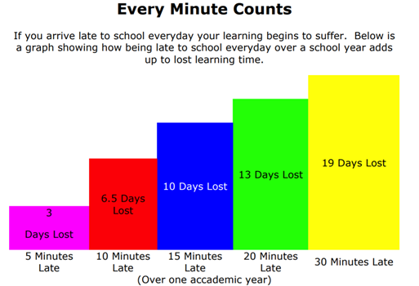

EVERY DAY COUNTS
Every minute is important
Lost minutes = Lost learning

