
Nursery Knowledge Organiser
Spring 1 – On the Move- Transport

Key Texts / Canon of works

Understanding the World

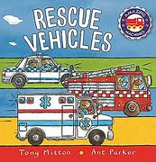
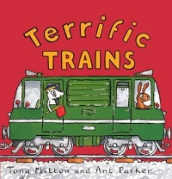
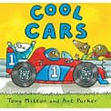
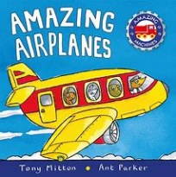
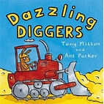

Literacy
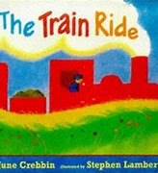
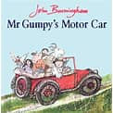
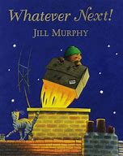
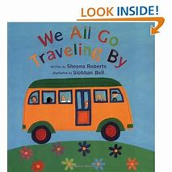
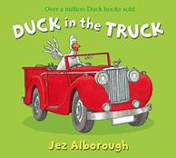


Key Concepts /Big Ideas
Journeys- what personal journeys do I remember?

How would I get to the other side of the world?

What are maps for?

Sky/ land or sea?

Key Questions and Vocabulary
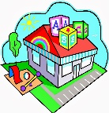
How do you travel to school?
We will discuss how the children get to school introducing the idea of a survey, collecting data using pictograms. Walk, car, bus, travel, journey.
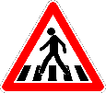
How do you cross the road safely?
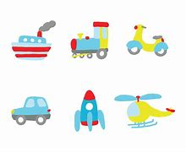
We will talk about road safety rules and why they are important. Using Super Cat’s Road Safety PowerPoint to introduce and discuss the rules, focusing on the main messages of stop, look, listen and think. We will also discuss how to stay safe when travelling in a car. The children will be able to strap Buddy our class bear into his car seat. Zebra crossing, green, go, amber, red, stop, look, left, right, car seat, seat belt.

How does it move?
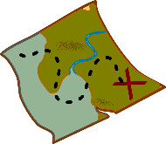
Using a variety of small world vehicles, pictures ad photographs the children will discuss similarities and differences. We will explore different ways of sorting them into categories such as ‘land, air or sea’ and ‘wheels or no wheels’. Land, sky, sea, track, boat, aeroplane, sort, wheels, wings, engine.

How do I get there?
The children will look at a variety of maps and discuss their purpose. We will then have a go at making our own maps. We will introduce positional language in order to give verbal instructions/ directions for games like ‘where’s Buddy?’ and ‘X marks the spot’. Pirate, treasure, over, under, on, in, next to, up, down, forwards, backwards.

Knowledge and Skills taught - Remembered Curriculum
Communication and Language   | Personal, Social and Emotional Development   | Physical Development  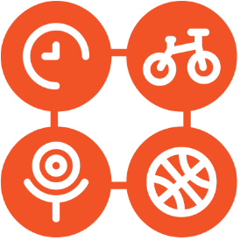 | Literacy   | Mathematics  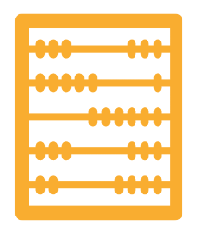 | Understanding the World   | Expressive Art and Design  
Enjoys listening to longer stories and can remember much of what happens.  Understand ‘why’ questions. | Select and use activities and resources, with help when needed.  Play with one or more other children, extending and elaborating play ideas.  Help to find solutions to conflicts and rivalries.  Increasingly follow rules, understanding why they are important.  Begin to understand how others might be feeling.  PSED – SCARF - Valuing Difference | Continue to develop their movement, balancing, riding and ball skills.  Go up steps and stairs, or climb up apparatus, using alternate feet.  Use large muscle movements to wave flags and streamers, paint and make marks.  Collaborate with others to manage large items, such as moving a long plank safely.  Show a preference for a dominant hand. | Understand the five key concepts about print.  Begin to engage in conversation about stories | Fast recognition of up to 3 objects, without having to count them individually (subitising).  Know that the last number reached when counting a small set of objects tells you how many there are in total (cardinal principle).  Show ‘finger numbers’ up to 5.  Compare quantities using language: ‘more than’. ‘fewer than’.  Describe a familiar route.  Talk about 3D shapes.  Select shapes appropriately.  Extend and create ABAB patterns. | Explore collections of materials with similar and/or different properties.  Explore how things work.  Show interest in different occupations.  Explore and talk about the different forces they can feel.  Talk about the differences between materials and changes they notice | Begin to develop complex stories using small world equipment like animal sets, dolls and dolls houses.  Explore different materials freely, in order to develop their ideas about how to use them and what to make.  Join different materials and explore different textures.  Create closed shapes with continuous lines, and begin to use these shapes to represent objects.  Use drawing to represent ideas like movement or loud noises.

