
Nursery Knowledge Organiser
Autumn 2 – Let’s celebrate! Birthdays and other celebrations.

Key Texts / Canon of works

Literacy

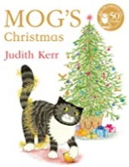
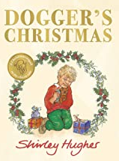
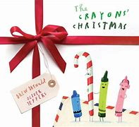
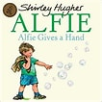
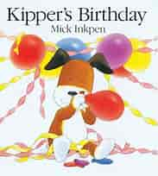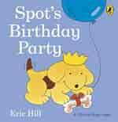

Understanding the World

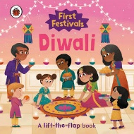
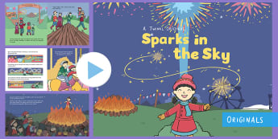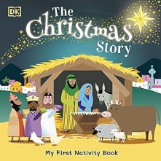


Key Concepts /Big Ideas.

Celebrations- how do people around the world celebrate?

Birthdays- when is my birthday? Why is my birthday special? How do other people celebrate?

Diwali Halloween Bonfire night Christmas

Key Questions and Vocabulary
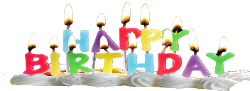
When is your Birthday? How old will you be?

The children will talk about their age and when their birthday is. How many children have birthdays in the same month? After sharing a range of books linked to ‘birthdays’, the children will work together to plan a special party for Buddy our class bear. This will involve everything from writing invitations to counting/ sharing out plates and cups as well as planning party games. Cake, cards, presents, candles, gift tags, balloons, celebrate, games, food, drinks, invitations.
How do we celebrate Bonfire Night?
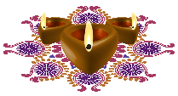
As well as exploring the shapes, colours and sounds made by fireworks; the children will learn how to stay safe when using sparklers. They will remember 3 main rules: 1. Wear gloves 2. Hold the sparkler away from your face and body with arms stretched 3. Dispose of sparkler in bucket of water or sand. Fireworks, sparklers, bonfire, Guy Fawkes, gloves, safe, whizz, pop, bang.
How is Diwali celebrated?

We will share the story of Rama and Sita on BBC teach but the focus of our Diwali work will be ‘how’ people celebrate as opposed to ‘why’. The children will learn watch a day in the life of a Hindu girl named Deeya as she talks about how she celebrates Diwali (Cbeebies My first festivals). We will be mark making as we design our own mendhi patterns and crafting our own diwa lamps. Diwali, lights, Rama, Sita, festival, Diva lights, Rangoli patterns, Mendhi patterns.
How do we celebrate Christmas?
Advent is all about getting ready for the arrival of baby Jesus. We will talk about how they would get ready for a baby coming. We will look at the numbers on an advent calendar together. We will learn a range of Christmas songs to sing with our parents at our Christmas craft morning. Christmas, Advent, party, presents, gifts, parcel, Father Christmas, Santa, reindeer, Rudolf, elf, The Nativity, Mary, Joseph, baby Jesus, angel, shepherds, wisemen, crib, gift.

Knowledge and Skills taught - Remembered Curriculum
Communication and Language   | Personal, Social and Emotional Development   | Physical Development  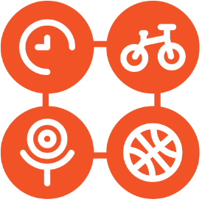 | Literacy   | Mathematics   | Understanding the World   | Expressive Art and Design  
Begin to build a repertoire of songs, rhymes and familiar books.  Can start a conversation with an adult or a friend.  Use talk to organise themselves and their play  Begin to use a wide range of vocabulary.  Begin to understand a question or instruction which has two parts. | Become more outgoing with unfamiliar people in the safe context of their setting.  Show more confidence in social situations.  Talk about their feelings using words like happy, sad, angry or worried.  Be increasingly independent in meeting their own care needs, e.g brushing teeth, using the toilet, washing and drying hands thoroughly.  PSED – SCARF - Valuing Difference | Start taking part in some group activities which they make up for themselves or in teams.  Begin to use one handed tools and equipment.  Be increasingly independent as they get dressed and undressed.  Be increasingly independent at meeting their own care needs.  Make healthy choices about food, drink, activity and toothbrushing. | Understand the five key concepts about print.  Begin to engage in conversation about stories | Recite numbers past 5.  One number for each item in order.  Talk about and explore 2D shape.  Understand position through words alone.  Talk about and identifies the patterns around them | Begin to make sense of their own life story and family’s history.  Begin to develop positive attitudes about the differences between people.  Use all their senses in hands on exploration of natural materials. | Take part in simple pretend play using an object to represent something else.  Explore colour and colour mixing.  Begin to remember and sing entire songs.  Listen with increased attention to sounds.

